

ARRIVING

By 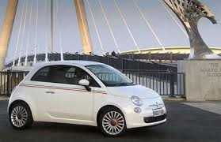
From the GRA (Rome's free Ring Road) take the exit 30 toward Fiumicino, then follow the road signs for “Fiera di Roma. .

USEFUL LINKS
- Avis Rent Car
- Maggiore Rent Car
- Hertz Rent Car
- Europcar Rent Car

By 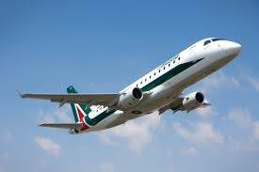
From Roma Fiumicino airport, it is possible to reach Fiera di Roma with the FR 1 train, Fiera di Roma stop (fare 8 euros), alternatively by taxi or Cotral buses.

USEFUL LINKS
- Rome Fiumicino airport
- Trenitalia.it
- Cotrail transports
- Radiotaxi.it

By 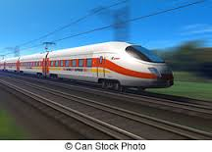
From Tuscolana, Tiburtina, Ostiense train stations, which are connected to the A and B lines of the underground (Metropolitana) take the train FR 1 toward Fiumicino and get off at Fiera Roma stop. Fare 1 euro.
USEFUL LINKS
- Trenitalia.com
- Romametropolitane.it
www.italotreno.it

